# Project Report

|  |  |
| --- | --- |
| Project Title | Plan, Schedule, Test Community Portal |
| Qualification Name (NICF) | NICF-Advanced Certificate in Infocomm Technology (Software and Applications) |
| Product Name | NICF-Capstone Project using Java |
| Module Name (NICF) | NICF-Capstone Project using Java |

|  |  |  |  |
| --- | --- | --- | --- |
| Student name | | Assessor name | |
| Chathushi Jayarathna | | MS.Aravinder Kaur | |
| Date issued | Completion date | | Submitted on |
| 10/10/2022 | 27/10/2022 | | 27/10/2022 |
|  | |  | |
| Project title | Plan, Schedule, Test Community Portal | | |

|  |
| --- |
| Learner declaration |
| I certify that the work submitted for this assignment is my own and research sources are fully acknowledged.  Student signature: **Chathushi**  Date: 27/10/2022 |

Table of Contents

1. Project Report 0

1. Project Background 3

2. Project Objective 4

2.1 Scope of Testing 4

2.1.1 In Scope 4

2.1.2 Out of Scope 4

**2.2** **Tools and Platforms used** 4

**2.3** **Preparation of test scripts** 6

2.4 Test Execution 6

3. Project Requirements Specifications 7

3.1 Software Programmers 7

3.2 Admin 7

3.3 Test methods 8

3.3.1 Testing Methods 8

3.3.2 Benefits of Test Methods 8

4. Requirement specification 9

4.1 Functional requirements 9

4.1.1 All pages in each module with a brief description and their purpose and each module which are create, edit and view pages 9

4.1.2 Sitemap of Public & Private Sites 10

4.2 Non-Functional Requirements 11

4.3 Technical Environment Requirements 12

4.4 Testing Requirements 12

5. Different types of testing 13

5.1 Functional Testing 13

5.1.1 Unit Testing 13

5.1.2 UAT Testing 14

5.2 Non-Functional testing 15

5.2.1 Cross-browser testing 15

5.2.2 Usability Testing 15

5.2.3 Load Testing 16

6.2 Non-Functional Testing 17

7. Optimal scheduling times for different tests 17

**9.** **Phase Test Plan** 18

**9.1** **Features to be tested** 19

**9.2** **Features Not to Be Tested** 19

**9.3** **Approach** 19

**9.4** **Suspension Criteria** 19

**9.5** **Resumption Criteria** 20

**9.6** **Exit Criteria** 20

1. Project Background

ABC Jobs Pte Ltd is a career guidance organization that gives tasks to individuals. That organization needs to foster a community portal to spread its name to additional clients

ABC Jobs Pte Ltd suggests occupations and recruits’ laborers. With this community portal, clients can enlist for themselves and quest the most prominent positions in their occupations. Likewise, clients can make networks with other clients by interfacing with them in their local area. Likewise, the gateway is principally utilized for proficient collaborating and vocational development

The primary motivation behind this task is to design and develop the community portal as they wish. Locally community portal clients will actually want to enroll and look for another client. After they can log in, reset their password, and update their profile. User details are stored in a database. This ABC Community portal entryway is very valuable to the client side since clients do not have to go to ABC Jobs organization to look through positions, they can look online with the local area gateway. Likewise, clients should need to safeguard a client profile to acquaint themselves. This people group entryway has private and public modules. Confidential modules approach for the administrators and public modules approach programming software engineers.

For this local community portal, we have carried out a java-based web application with a spring MVC structure for the client necessities, business needs, and cycles. Likewise, we want to design, make, plan and execute the tests for this undertaking. As a component of this task, we really want to recognize this problem and oversee it across its lifecycle

1. Project Objective
   1. Scope of Testing
      1. In Scope

* Registration Page
* Registration Confirmation
* Thank You Page
* Login Page
* User Profile Page
* Update Profile Page
* Admin Page
* Forgot Password Page
* Forgot Password Confirmation Page
* Search User Page
* Bulk Email
* Job posting
  + 1. Out of Scope
* Post Threads
* Send Messages
  1. **Tools and Platforms used**
* 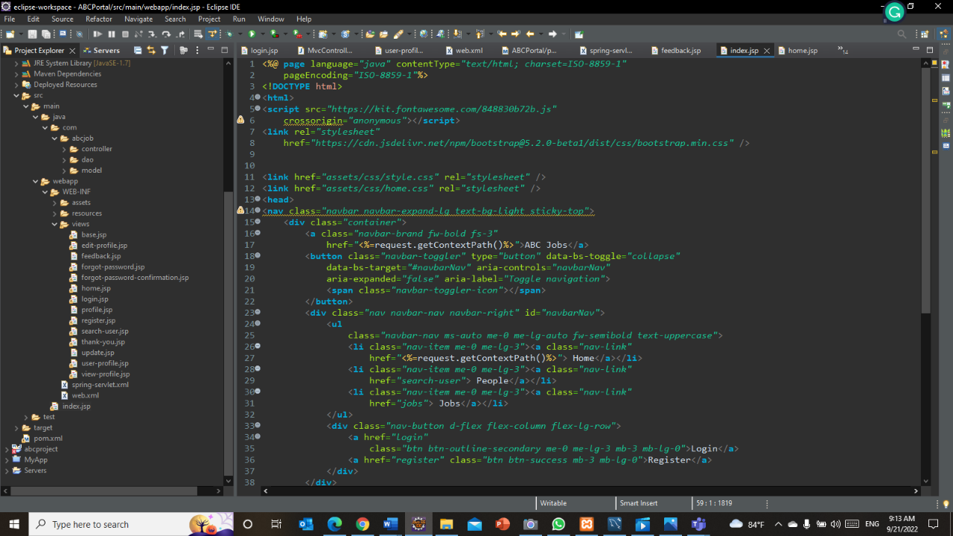Eclipse IDE for Enterprise Java and Web Developers - 2022- 03 – To implement application

Figure :Screenshot of Eclipse IDE

* 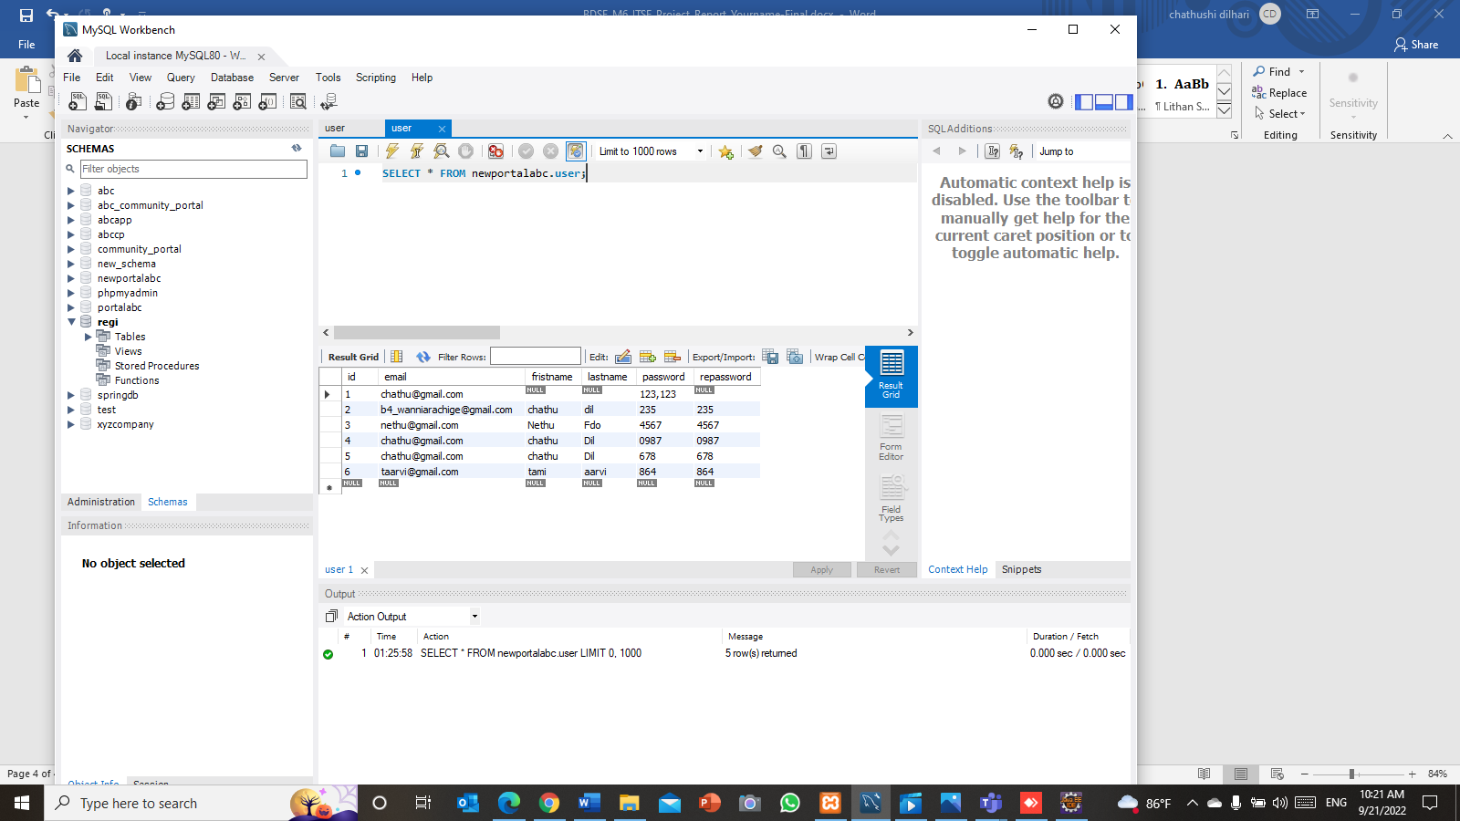MySQL Workbench 8.0 CE – To create ate database

Figure :Screenshot of MySQL Workbench

* 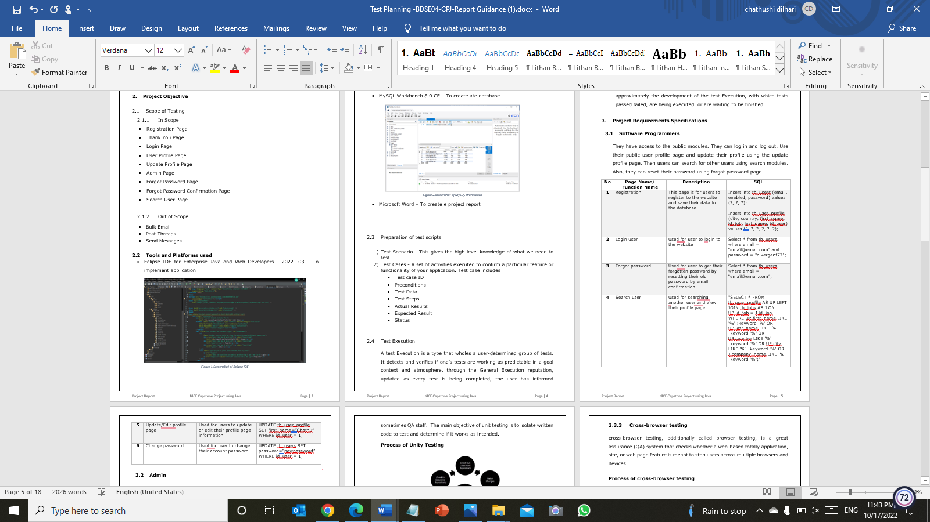Microsoft Word – To create e project report

Figure :Screenshot of Microsoft Word

* Microsoft PowerPoint – To create project presentations

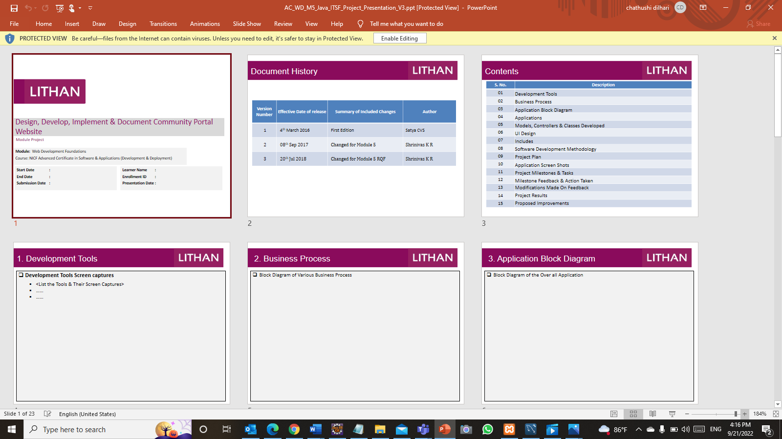

Figure :Screenshot of Microsoft PowerPoint

* 1. **Preparation of test scripts**

1. Test Scenario - This gives the high-level knowledge of what we need to test.
2. Test Cases - A set of activities executed to confirm a particular feature or functionality of your application. Test case includes

* Test case ID
* Preconditions
* Test Data
* Test Steps
* Actual Results
* Expected Result
* Status
  1. Test Execution

A test Execution is a type that wholes a user-determined group of tests. It detects and verifies if one’s tests are working as predictable in a goal context and atmosphere. through the General Execution reputation, updated as every test is being completed, the user has informed approximately the development of the test Execution, with which tests passed failed, are being executed, or are waiting to be finished

1. Project Requirements Specifications
   1. Software Programmers

They have access to the public modules. They can log in and log out. Use their public user profile page and update their profile using the update profile page. Then users can search for other users using search modules. Also, they can reset their password using forgot password page

|  |  |  |
| --- | --- | --- |
| No | Page Name/ Function Name | Description |
| 1 | Registration | This page is for users to register to the website and save their data to the database |
| 2 | Login user | Use for user to login to the website |
| 3 | Forgot password | Use for user to get their forgotten password by resetting their old password by email confirmation |
| 4 | Search user | Use for searching another user and view their profile page |
| 5 | Update/Edit profile page | Use for users to update or edit their profile page information |
| 6 | View Job | Use for user to view jobs |
| 7 | Apply Job | Use for user to apply jobs |

* 1. Admin

Admin has access to private modules. Admin can log in and log out. Can use the admin profile page also. They have access to the search users pages and they can add, a posting module. Also, admin can reset their password using password retrieval functionality

|  |  |  |
| --- | --- | --- |
| No | Page Name/ Function Name | Description |
| 1 | Login admin | Use for admin to log in as an administrator of the website |
| 2 | Add user | Use for adding a new user |
| 3 | Edit user | Use for editing user data |
| 4 | Delete user | Use for deleting user data |
| 5 | Post Jobs | Use for post jobs |
| 6 | Bulk Email | Use for send emails to users |
| 7 | View Job Responses | Use for view job responses |
| 5 | List Job | Use for view posted job list |

* 1. Test methods
     1. Testing Methods

1. Unit testing
2. UAT testing
3. Cross-browser testing
4. Usability testing
   * 1. Benefits of Test Methods

* Unit Testing - Unit testing confirms that all code meets quality values formerly it's deployed. Also, it saves time and, money
* UAT Testing - UAT is the last part of the whole testing process of the software. Its faster and cheaper to fix usability issues in the early stages
* Cross-browser Testing - It let you check on different OS browser settings
* Usability Testing - Usability testing also identified as user testing, includes gathering data from actual users on a website, application or prototype

Task 1

1. Requirement specification

4.1 Functional requirements

* Public Module- Software Programmers, External Parties
* Registration Page
* Login Page
* Forgot Password Page
* Forgot Password Confirmation Page
* User Profile Page
* Update Profile Page
* Search User Page
* Apply Job
* Private Module – Admin
* Registration Page
* Login Page
* Forgot Password Page
* Admin Profile Page
* Bulk Email Page
* Job Posting Page
* View Job Responses
* List Job
* Search User Page
* Update and Delete page
  + 1. All pages in each module with a brief description and their purpose and each module which are create, edit and view pages

|  |  |  |  |
| --- | --- | --- | --- |
| **No** | **Web Page/ Process** | **Requirements** | **Page Functions (create, edit, view, delete)** |
| 1 | Registration | Users can register on the register page | Create |
| 2 | Login | Users can log in to the login page | View |
| 3 | Forgot Password | Users can request a reset forgotten password | View & edit |
| 4 | Logout | Users can logout from the website | View |
| 5 | Search Users | Users can search other user | View |
| 6 | Update Profile | User can update their profile | Edit |
| 7 | User Profile | Users can view other user profile | View |
| 8 | Apply Job | Users can apply for the job that exists in the website | View & edit |
| 9 | Login admin | Used for admin to log in as an administrator of the website | View |
| 10 | Dashboard | Administrator page to manage all the users of the website, this page includes add, view list user, edit user, delete user, send bulk email, posting job and accepting user to the job functionality. | View, edit, create, delete |
| 11 | Posting jobs | Used for posting jobs opportunity to the software programmers/user of the website | Create |
| 12 | Send bulk email | Used for sending bulk email to all the users | Create |
| 13 | Send Messages | Used for send messages between users | View |

* + 1. Sitemap of Public & Private Sites

In this community portal, there are two modules which are private and public. Public modules are for software programmers which are external parties. The private module is for admins of the community portal. Both users and admins can log in to the community portal using the same login page. If they forgot their password, they can reset it using forgot password link in login page. Using Spring security software are programmers redirected to the user profile and are admins the redirected to admin user profile. Admins have the access to private modules such as Delete, Edit Add user pages, send bulk emails, Post jobs, view job responses etc. Software programmers only have access to their profile pages. They can view their profile, edit and update their profile, search other users in ABC Community portal, View Jobs and Apply job.

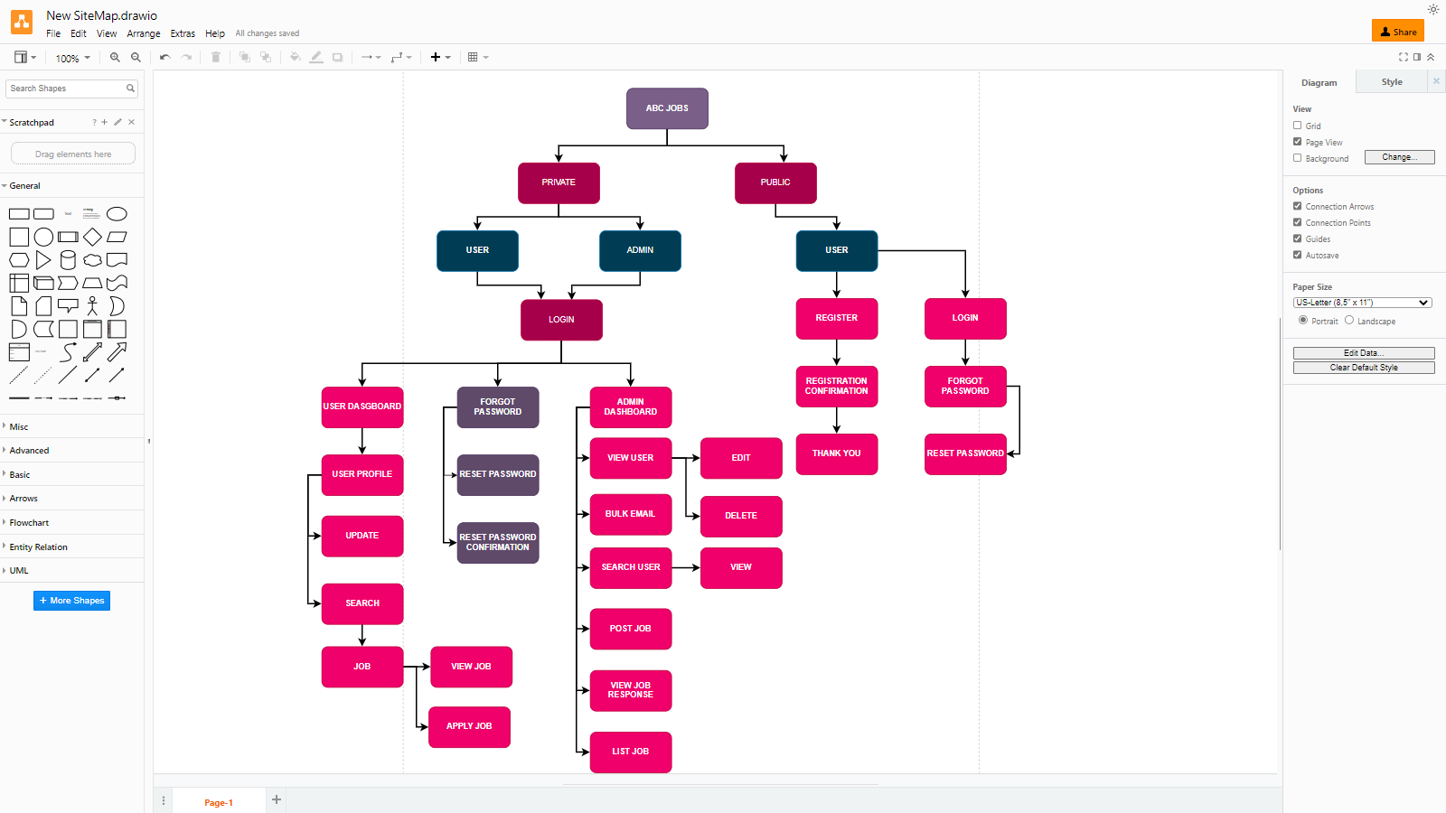

Figure :Sitemap of Public & Private Sites

* 1. Non-Functional Requirements

1. Portability Requirements

* Multi OS - Windows, Linux, and Mac
* Multiple Browsers - Chrome, Safari
* Multiple Devices - Desktop, Tablet

1. Maintainability Requirements

* Database is backing up every 6 hours
* Vulnerability check - periodical scanning
* Each request should be processed within 10 seconds

1. Performance Requirements

* Concurrent number of users - 100
* Loading time - 15sec

1. Security Requirements

|  |  |  |  |
| --- | --- | --- | --- |
| .permit all() | .hasAnyRole | .hasRole(“Admin”) | .hasRole(Softwere programmer) |
| Index.jsp | Index.jsp | Adminwelcome.jsp | Registration.jsp |
| Registration.jsp | Registration.jsp | index.jsp | ViewProfile.jsp |
| Home.jsp | Home.jsp |  | Forgotpassword.jsp |
| EditProfile.jsp | EditProfile.jsp |  |  |

* 1. Technical Environment Requirements

1. Hardware Requirements

* Processor: Inter(R) Core(TM) i5
* RAM: 12GB
* 1TB Disk Space
* MySQL Server 8.0.30
* Apache Tomcat 9

1. Software Requirements

* Development Environment - JDK 8.1
* Framework - Spring MVC
* Database Server - MySQL Server 8.0.30
* Firewall Settings - Port 9001-Http,Port 3306 - Database

1. System Integration Requirements

* JDBC-JDBC Connector 8.0.11
* Spring security Dependency
  1. Testing Requirements
* System and application - Completely developed community portal using Spring MVC, Spring Framework
* Test Data - We need to prepare test data
* Database Server - MySQL Server
* Front End running environment - Use jsp file for the front-end system
* Client Operating System - Windows OS
* Browser - Google Chrome, Mozilla Firefox, Microsoft Edge
* Server - Apache Tomcat Server
* Network

Task 2

1. Different types of testing
   1. Functional Testing
      1. Unit Testing

Unit testing is a [software](https://www.techtarget.com/searchapparchitecture/definition/software) development process in which the smallest testable parts of an [application](https://www.techtarget.com/searchsoftwarequality/definition/application), called units, are individually and independently scrutinized for proper operation. This testing methodology is done during the development process by the software developers and sometimes QA staff.  The main objective of unit testing is to isolate written code to test and determine if it works as intended.

* Helps developers write better code
* It helps developer to catch bugs earlier
* It makes the code easier to refactor

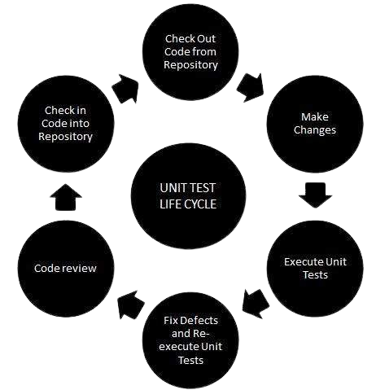 **Process of Unit Testing**

Figure :Process of Unit Testing

* + 1. UAT Testing

UAT (User Acceptance Testing) is a type of testing performed by the end-user or the client to verify the software system before moving the software application to the production environment. UAR is done in the final phase of testing after functional, integration, and system testing is done

* Keeping ongoing maintenance costs as low as possible
* Increase end-user happiness
* Increasing software robustness and usability

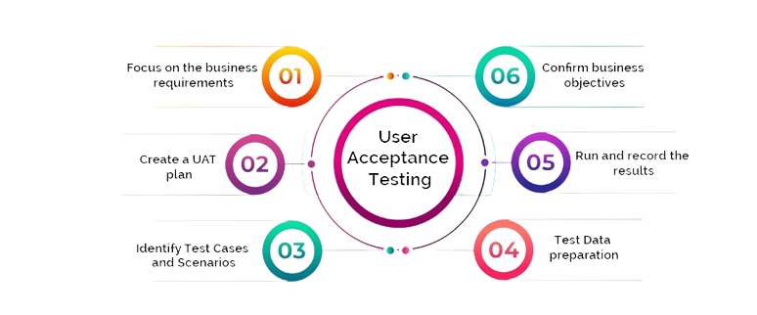**Process of UAT testing**

Figure :Process of UAT Testing

* 1. Non-Functional testing

5.2.1 Cross-browser testing

cross-browser testing, additionally called browser testing, is a great assurance (QA) system that checks whether a web-based totally application, site, or web page feature is meant to stop users across multiple browsers and devices.

* **Reduction of repetitive work**
* **Greater consistency and repeatability**
* **Ease of access to information about tests or testing**

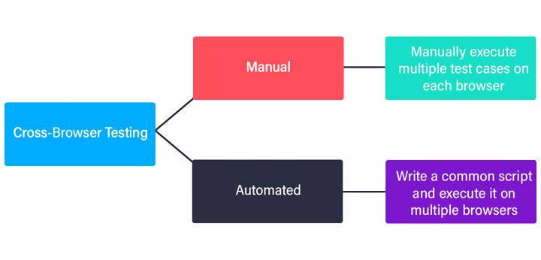Process of cross-browser testing

Figure :Process of cross-browser testing

5.2.2 Usability Testing

Usability testing additionally called user to enjoy(UX) trying out, is a testing method for measuring how easy and user-friendly a software program application is. A small set of goal quit-users, use software to show usability defects. Usability testing mainly specializes in a person’s ease of use of software, the flexibility of utility to address the controls, and the potential of application fulfil its goals.

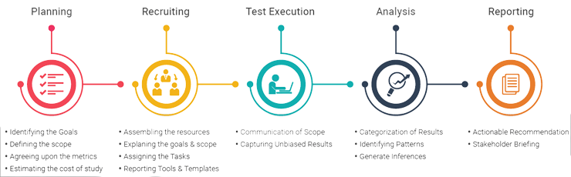**Process of Usability Testing**

Figure :Process of Usability Testing

5.2.3 Load Testing

Load testing is a sort of performance testing that determines the overall performance of a device, software product, or software utility below actual life primarily based on load conditions. basically, load testing determines the behavior of the utility while multiple users use it at the identical time. It is the reaction of the system measured under various load conditions. The burden testing is finished for regular and severe load conditions

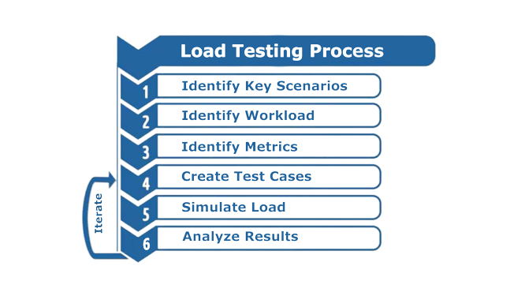**Process of Load Testing**

Figure :Process of Load Testing

Task 3

1. Relevant tests suitable for the Project Scenario
   1. Functional Testing

* Unit Testing – Unit test development speed is faster. Unit tests are easier to debug, and you can have more reliable code
* UAT Testing – It reduces the maintenance fee as much as possible. It develops software usability
  1. Non-Functional Testing
* Cross-browser Testing - By testing with different OS web browsers, we can ensure that the application works smoothly in those different browsers.
* Load Testing
* Usability Testing

Task 4

1. Optimal scheduling times for different tests

Scheduling

1. Weighting (1 - 3)

* 1 – Simple
* 2 – Medium
* 3 – Complex

1. Functional points (1 - 5)

* 1 - 2 – If rarely used
* 3 - 4 – Often used
* 5 – Most often used

|  |  |  |  |  |
| --- | --- | --- | --- | --- |
| No | Web page | Weighting | Functional Points (FP) | Total |
| 1 | Registration | 3 | 5 | 15 |
| 2 | Login | 2 | 3 | 6 |
| 3 | Logout | 1 | 3 | 3 |
| 4 | Forgot Password | 3 | 3 | 9 |
| 5 | Search Users | 2 | 4 | 8 |
| 6 | Update user profile | 2 | 2 | 4 |
| 7 | View user profile | 1 | 5 | 5 |
| 8 | Posting Jobs | 2 | 2 | 4 |
| 9 | View User Response | 2 | 5 | 10 |
| 10 | Send bulk email | 3 | 2 | 6 |
| 11 | Apply Job | 3 | 3 | 9 |
|  | Total functional points | | | 79 |
|  | Estimated person hour/ FP | | | 2 |
|  | Total hours needed | | | 158 |
|  | Total days needed (8h/day) | | | 19 |

1. **Test Schedule**

|  |  |  |  |
| --- | --- | --- | --- |
| Test Schedule ID : | TS001 |  |  |
| Product ID / Name : | ABC Community Portal |  |  |
| Product Version or Build: | 1.0 |  |  |
| Present Owner : | ABC PVT LTD |  |  |
| Created On : | 25/09/2022 |  |  |
| Review On : | 12/10/2022 |  |  |
| Review By : | Chathu | QA Manager |  |
| Review Comments : | Good |  |  |
| Current Version : | 1.0 |  |  |
| Change Details : | Not Available |  |  |
| Current Status : | Approved |  |  |
| Signing Off Authority : | Kevin, Leo, Kara | Software Developer, QA Manager, Client | 10/07/2022 |

Task 5

1. **Phase Test Plan**

|  |  |  |  |  |  |
| --- | --- | --- | --- | --- | --- |
| No | Task | Start | End | Person Days | Resource |
| 1 | Prepare Test Plan | 25 Sep 2022 | 29 Sep 2022 | 3 | QA Manager, QA |
| 2 | Define metrics | 30 Sep 2022 | 30 Sep 2022 | 1 | QA Manager, QA |
| 3 | Review plan | 1 Oct 2022 | 1 Oct 2022 | 1 | QA Manager, QA |
| 4 | Prepare Test Scripts | 2 Oct 2022 | 4 Oct 2022 | 2 | QA Manager, QA |
| 5 | Review Test Scripts | 5 Oct 2022 | 5 Oct 2022 | 1 | QA Manager, QA |
| 6 | Set up Test Environment | 6 Oct 2022 | 6 Oct 2022 | 1 | QA Manager, QA |
| 7 | Execute Testing/Record Faults | 7 Oct 2022 | 9 Oct 2022 | 2 | QA Manager, QA |
| 8 | Re-execute Test as Needed | 10 Oct 2022 | 10 Oct 2022 | 1 | QA Manager, QA |
| 9 | Document the test results | 11 Oct 2022 | 11 Oct 2022 | 1 | QA Manager, QA |
| 10 | Review Document | 12 Oct 2022 | 12 Oct 2022 | 1 | QA Manager, QA |

**Goal**

The goal of this test is to identify and measure the problems/ issue in the web application and implementing the community portal website for the ABC Jobs Pvt Ltd.

**Objectives**

Validate and verify system functionality works according to requirements

* 1. **Features to be tested**
* Registration
* Login
* Logout
* Reset Forgot Password
* Search users
* Posting Job
* Applying Job
* Send Bulk Emails
  1. **Features Not to Be Tested**
* Send Messages
* Posting Threads
  1. **Approach**
* Unit Testing
* Cross Browser Testing
* UAT
  1. **Suspension Criteria**

Component testing will be suspended under the following conditions:

* Prevent the test completion because of complex errors
* When steps are disturbed, can't do any further testing
* Development and testing were suspended because the e of day off
* Critical errors found preventing test completion
  1. **Resumption Criteria**

Component testing will resume when the following criteria are met:

* All issues in suspension criteria have been resolved or mitigated
* New software build has been redistributed
* New build with fixed critical
* The day off periods ends
* When all the errors can resolve, we can do the testing.
  1. **Exit Criteria**

Component testing can be considered complete when the following conditions have been met:

* All test scripts are executed
* No defect found in test scenarios on this community portal application.
* No critical bugs have been left on testing process
* Closure the all identified defects
* Deadline not meets
* Ready the all deliverables
* All expects and actual results are captures, and documented correctl
* All High and Medium priority requirements have been tested without Critical or Medium severity defects.
  1. **Test Metrics**
* No of test cases
* No of test cases executed
* No of test cases passed
* No of test cases failed
* Total failures and passes
* Test case execution time
  1. **Test Deliverables**
* Phase Test plan
* Test schedules
* Test scripts
* Test Results
* Bugs write-up

Task 6

1. Execute the tests and provide the reports
   1. Test Scenario 1: Unit Testing

|  |  |  |  |
| --- | --- | --- | --- |
| Requirements | Test Scenario ID | Test Scenario | Number of test cases |
| Functional Testing | TS001-Unit testing | Ensure that the user enters the correct data on the registration page | 1 |
| Check login functionalities | 1 |
| Check forgot password functionalities | 1 |
| TS002-UAT testing | 1. Check that a navigation menu is provided on each page and is consistent. | 3 |
| Non-Functional Testing | TS003-Cross Browser testing | 1. Check that the application is running normally on multiple web browser | 2 |

|  |  |
| --- | --- |
| Test Scenario | Ensure that the user enters the correct data on the registration page |
| TS001 |
| Test Cases | **Unit Testing** |
| TC001 | Check all the mandatory fields are entered |
| TC002 | Check the email-address validation working correctly |
| TC003 | Check post submission loading of thank you page |

Registration

|  |  |  |  |  |  |  |  |
| --- | --- | --- | --- | --- | --- | --- | --- |
| **Test Case ID** | **Test Case** | **Preconditions** | **Test Step** | **Test Data** | **Expected Results** | **Actual Results** | **Pass / Fail** |
| TC001 | Test Case 1 | The user should have the URL of the website and open the homepage of the abcjobs.com | * Type URL * Click “Sign up” on the website home page linked to the registration page. * Enter all the fields. * Click submit. * Run Junit4 | Name = Chathu  Email = [chathu@gmail.com](mailto:chathu@gmail.com)  Phone = 0742269976  City = Colombo  Password = 12345  Repeat Password = 12345 | Not register | As expected, | Pass |
| TC002 | Test case 2 | The user should have the URL of the website and open a homepage of the abcjobs.com | * Type URL * Click “Sign up” on the website home page linked to the registration page. * Enter all details except the name * Click submit. | Name = chathu  Email =chathushi0707@gmail.com  Phone = 0742269976  City = Colombo  Password = 12345  Repeat Password = 12345 | Email will sent to the registered email account | As expected, | pass |
| TC003 | Test case 3 | The user should have the URL of the website and open a homepage of the abcjobs.com | * Type URL * Click “Sign up” on the website home page linked to the registration page. * Enter all the fields * Enter all details except the email address * Click submit. | Full Name: Chathushi Jayarathna  Email Address: chathushi0707@gmail.com  Phone Number:0742269976  Select Gender: Female  Password: 1234  Repeat Password:1234 | Data will be saved in the database | As expected, | pass |

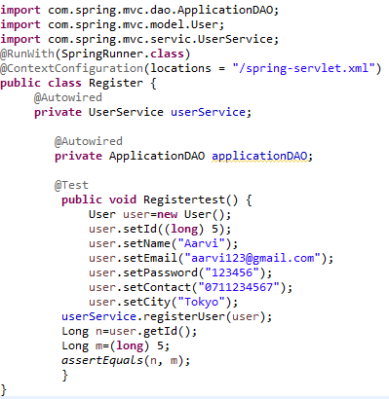

**Login**

|  |  |  |  |  |  |  |  |
| --- | --- | --- | --- | --- | --- | --- | --- |
| **Test Case ID** | **Test Case** | **Preconditions** | **Test Step** | **Test Data** | **Expected Results** | **Actual Results** | **Pass / Fail** |

|  |  |  |  |  |  |  |  |
| --- | --- | --- | --- | --- | --- | --- | --- |
| TC001 | Test Case 1 | The user should have the URL of the website and open a homepage of the abcjobs.com | * Type URL * Fill up the form of login with already registered an account. * Click submit. * Run Junit4 | Email = [chathushi0707@gmail.com](mailto:chathushi0707@gmail.com)  Password = 1234567 | Loaded welcome t hank you page | As expected, | Pass |
| TC002 | Test case 2 | The user should have the URL of the website and open a homepage of the abcjobs.com | * Type URL * Click “Sign up” on the website home page linked to the registration page. * Fill up the form with wrong password * Click submit. | Email = [chathushi0707@gmail.com](mailto:chathushi0707@gmail.com)  Password = 12345 | Welcome thank you page not loaded | As expected, | pass |

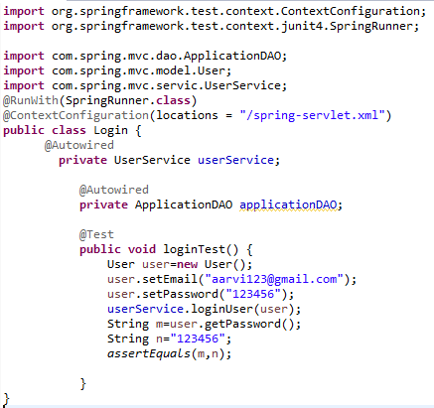

**Forgot Password**

|  |  |  |  |  |  |  |  |
| --- | --- | --- | --- | --- | --- | --- | --- |
| **Test Case ID** | **Test Case** | **Preconditions** | **Test Step** | **Test Data** | **Expected Results** | **Actual Results** | **Pass / Fail** |
| TC001 | Test Case 1 | The user should have the URL of the website and open the homepage of the abcjobs.com | * Type URL * Click “Login” on the website home page * Then click “forgot password” link in login page * Input the email address of an existing account * Click submit. * Run Junit4 | Email : chathushi0707@gmail.com | Received the password link to the email | As expected, | Pass |
| TC002 | Test case 2 | The user should have the URL of the website and open a homepage of the abcjobs.com | * Type URL * Click “Login” on the website home page * Then click “forgot password” link in login page * Click submit. | Email: ------- | Email address required | As expected, | pass |
| TC003 | Test case 3 | The user should have the URL of the website and open a homepage of the abcjobs.com | * Type URL * Click “Login” on the website home page * Then click “forgot password” link in login page * Input wrong email address * Click submit. | Email: chathushi777@gmail.com | The waring message should display |  | pass |

* 1. **Test Scenario 2: User Acceptance Testing (UAT)**

|  |  |  |  |
| --- | --- | --- | --- |
| Requirements | Test Scenario ID | Test Scenario | No of test cases |
| Functional Testing | TS003 | Landing | 2 |
| TS004 | Registration | 2 |
| TS005 | Login | 2 |
| TS006 | Forgot Password | 2 |

|  |  |
| --- | --- |
| Test Scenario | Landing Page |
| TS003 |
| Test Cases | **UAT Testing** |
| UAT01 | Check each hyperlink menu is loading correct page |

|  |  |  |  |  |  |  |  |  |  |
| --- | --- | --- | --- | --- | --- | --- | --- | --- | --- |
| Scenario ID | Test Case ID | Test Case | Preconditions | Test Step | Test Data | Expected Results | Actual Results | Pass / Fail | Evidence |
| TS003 | UAT01 | Check hyperlink menu is loading the correct page | The user should have the URL of the website and open a homepage of the abcjobportal.com | Go to Microsoft Edge  Type www.abcjobportal.com and enter  Click on all the links provided for test | Click on the register link | Loaded Register page | As expected, | Pass | UAT 01(1)  UAT 01(2) |
| Click on the login link | Loaded Login Page | As expected, | Pass | UAT 01(1)  UAT 01(3) |

**TS003 – Landing Page**

**TS003 - UAT01(1)**

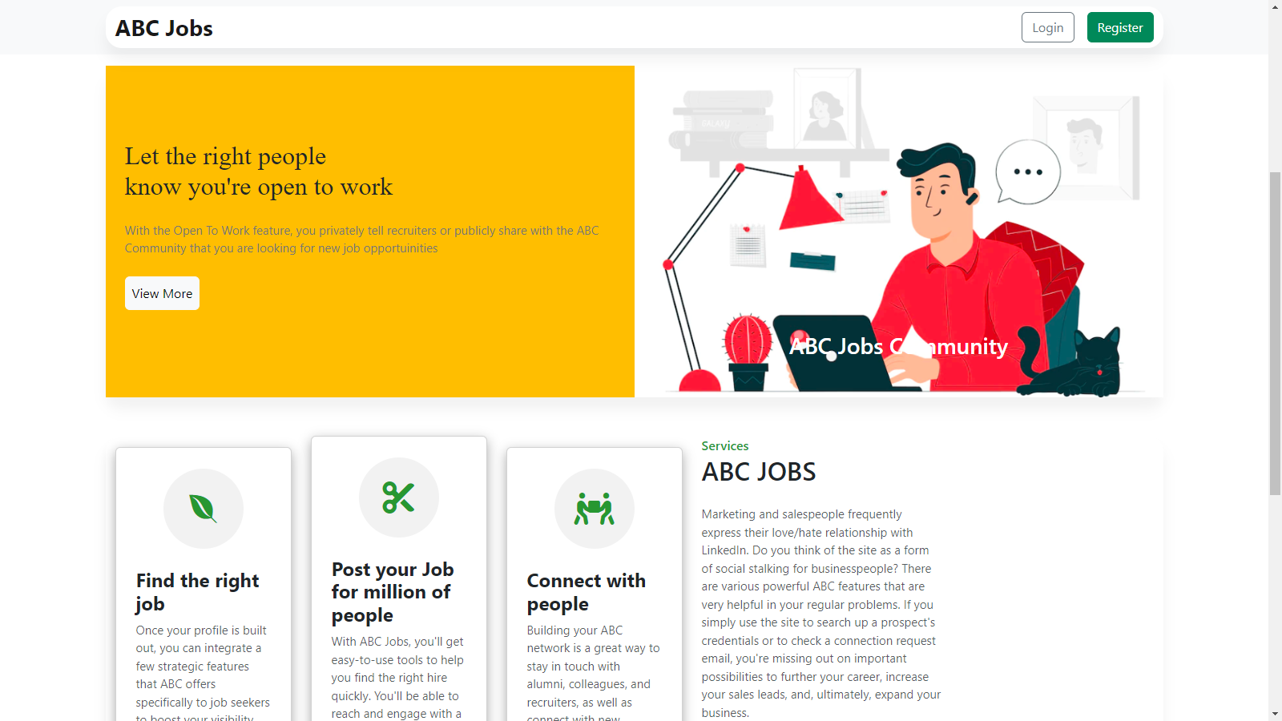

Figure :TS003 - UAT01-Screenshot of Landing Page

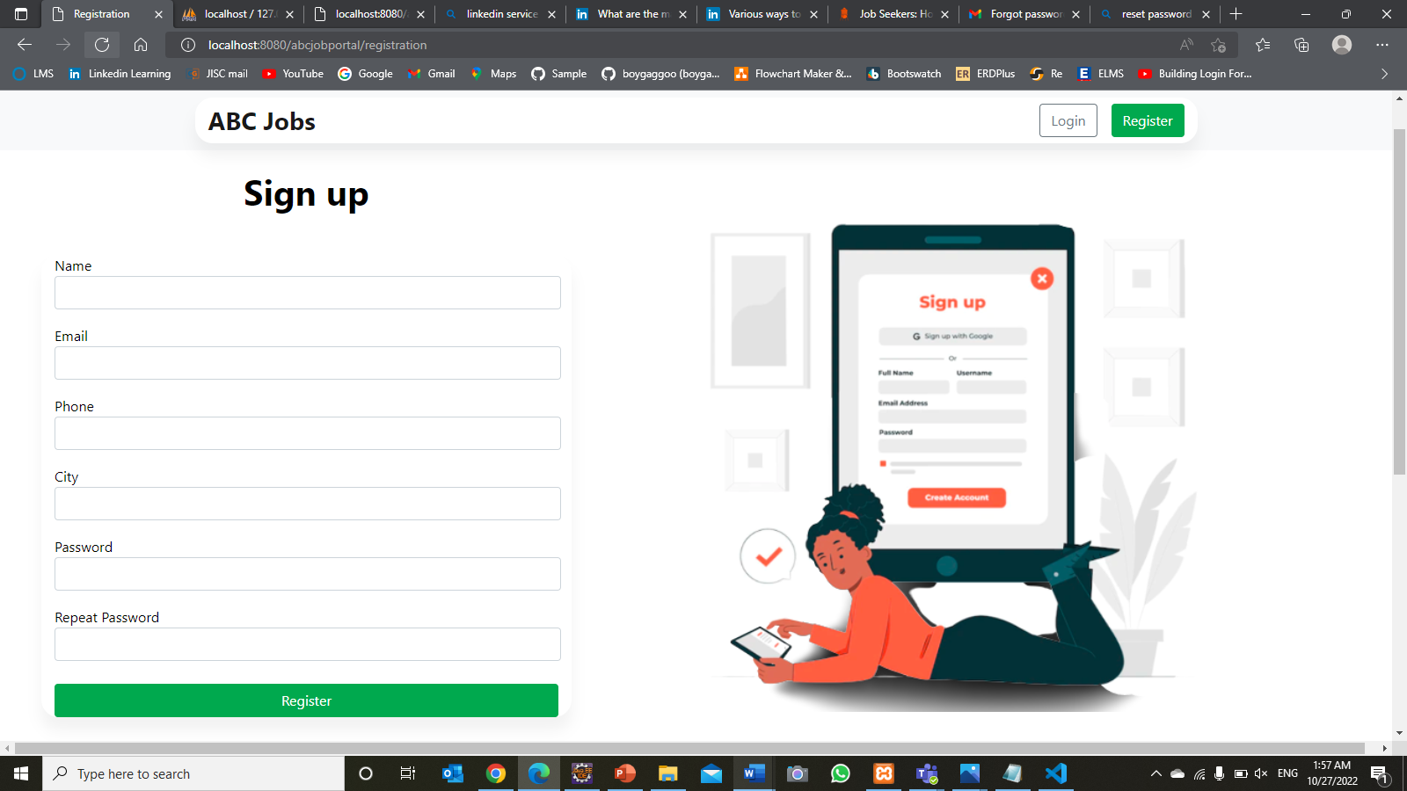**TS003 - UAT01(2)**

Figure :TS003 - UAT01-Screenshot of Login Page

**TS003 - UAT01(3)**

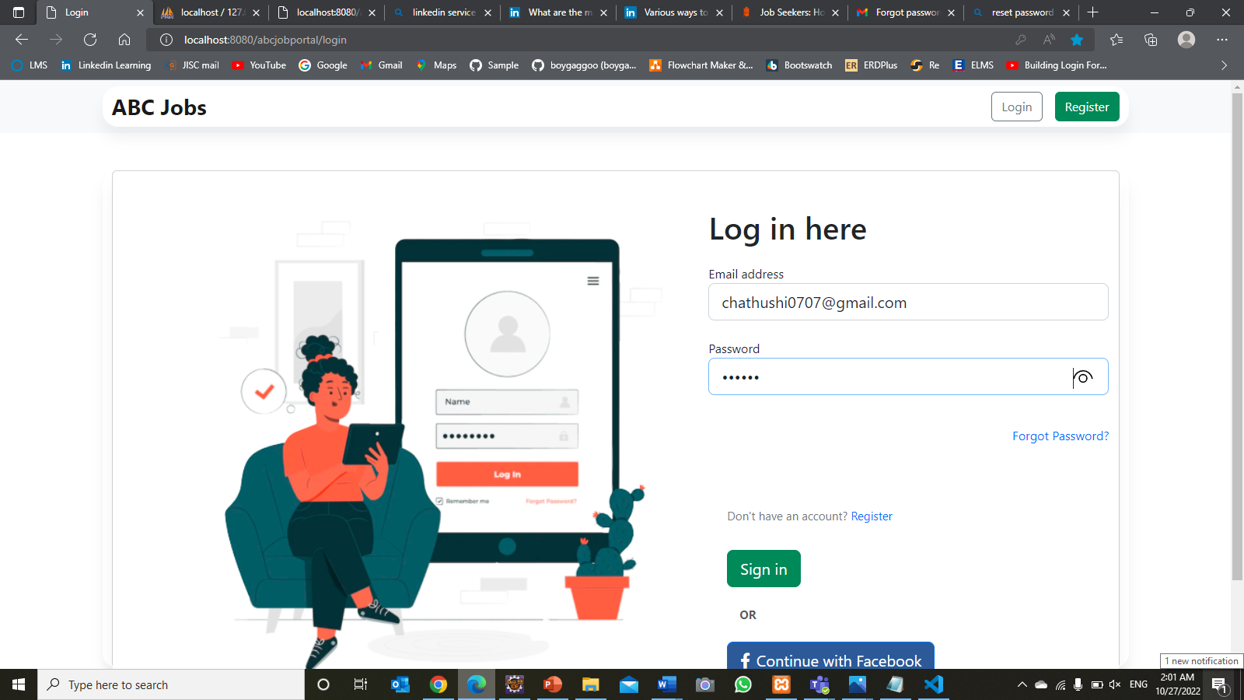

Figure :TS003 - UAT02-Screenshot of Login with details

|  |  |
| --- | --- |
| Test Scenario | Registration |
| TS004 |
| Test Cases | **UAT Testing** |
| UAT01 | Check registration data stored in database |
| UAT02 | Check each hyperlink menu is loading correct page |

|  |  |  |  |  |  |  |  |  |  |
| --- | --- | --- | --- | --- | --- | --- | --- | --- | --- |
| Scenario ID | Test Case ID | Test Case | Preconditions | Test Step | Test Data | Expected Results | Actual Results | Pass / Fail | Evidence |
| TS004 | UAT 01 | Check registration data stored in database | The user should have the URL of the website and open a homepage of the abcjobportal.com | Go to Microsoft Edge  Type www.abcjobportal.com and enter  Click on all the links provided for test | Fill up registration form | Loaded registration thank you page and registered data stored in database | AS expected, | Pass | UAT  01(1)  UAT 01(2) |
| TS004 | UAT02 | Check hyperlink menu is loading the correct page | The user should have the URL of the website and open a homepage of the abcjobportal.com | Go to Microsoft Edge  Type www.abcjobportal.com and enter  Click on all the links provided for test | Fill up registration form and click register link | Loaded registration thank you page | As expected, | Pass | UAT 02(1) |
| Click on the login link | Loaded Login Page | As expected, | Pass |  |

**TS004 – UAT01(1)**

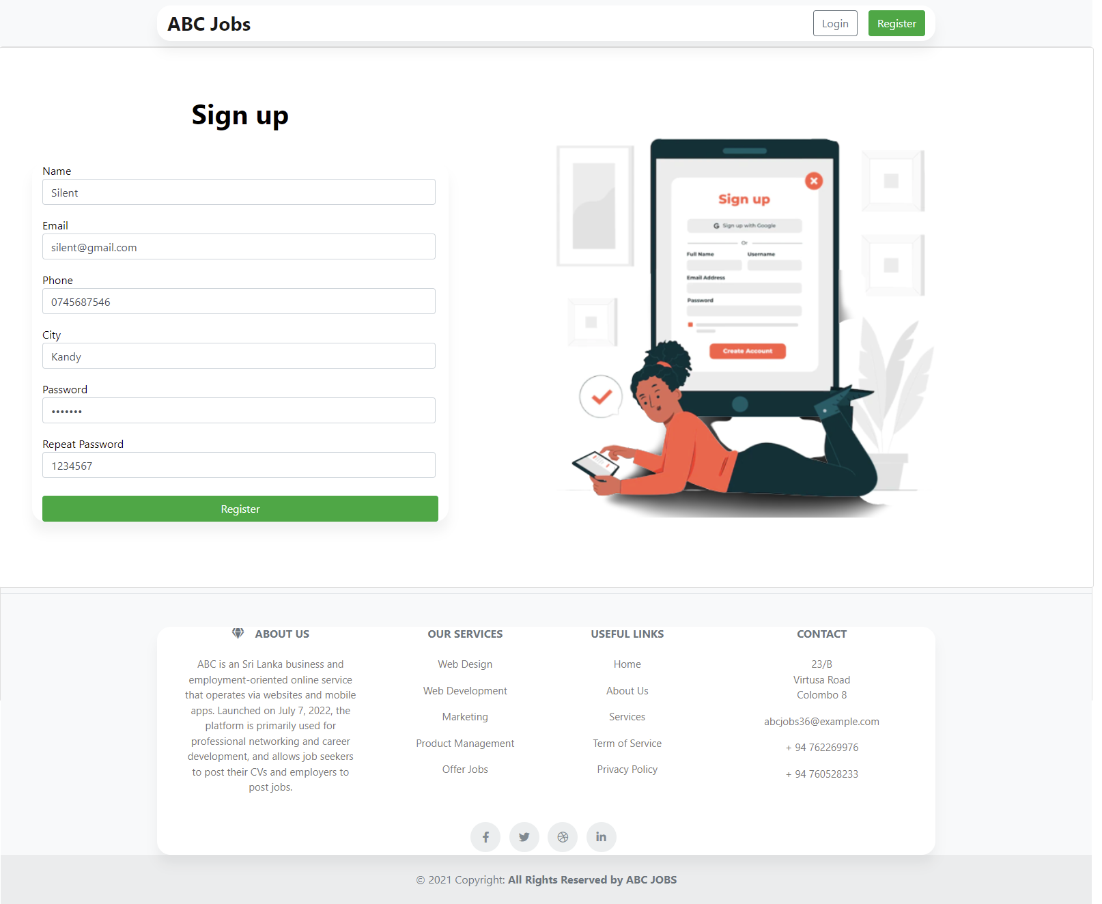

Figure :TS004 - UAT01(1) Screnshot of Registration Page with details

**TS004 – UAT01(2)**

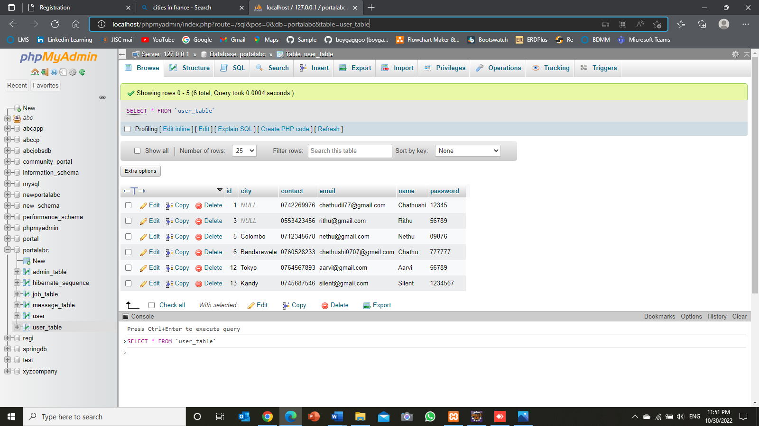

Figure :TS004 - UAT01(2) Screenshot of Database

**TS004 – UAT02(1)**

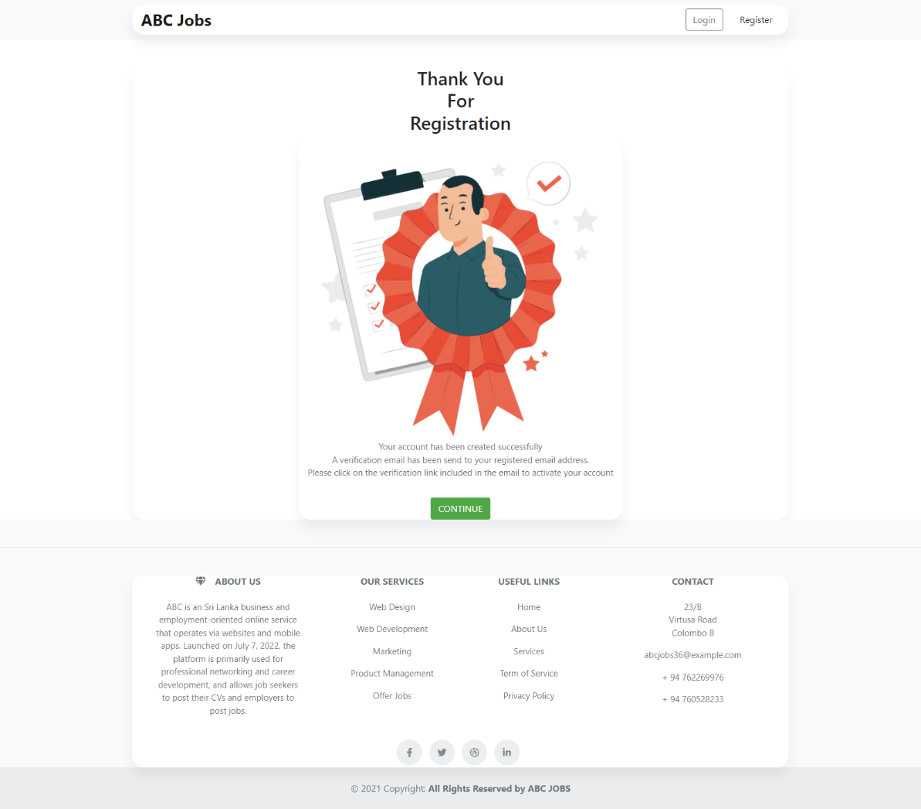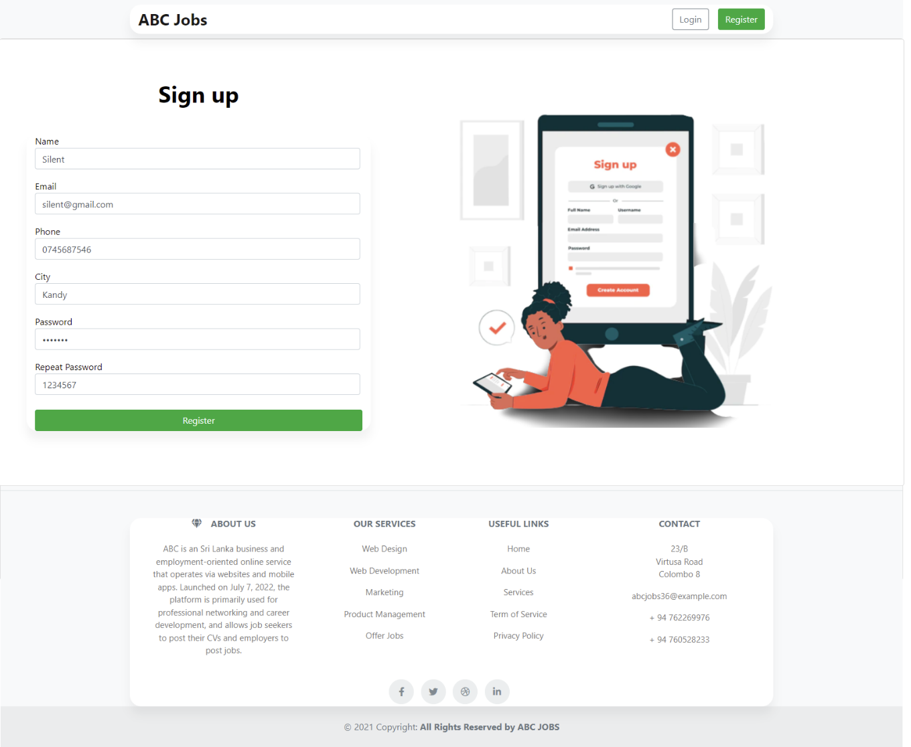

Figure :UAT02-Screenshot of User Profile Page

Figure :UAT02-Screenshot of User Home Page

|  |  |
| --- | --- |
| Test Scenario | Login |
| TS005 |
| Test Cases | **UAT Testing** |
| UAT01 | Enter user name and password then check user profile is loading |
| UAT02 | Check clicking the forgot password link |

|  |  |  |  |  |  |  |  |  |  |
| --- | --- | --- | --- | --- | --- | --- | --- | --- | --- |
| Scenario ID | Test Case ID | Test Case | Preconditions | Test Step | Test Data | Expected Results | Actual Results | Pass / Fail | Evidence |
| TS005 | UAT 01 | Enter user name and password then check user profile is loading | The user should have the URL of the website and open a homepage of the abcjobportal.com | Go to Microsoft Edge  Type www.abcjobportal.com and enter  Click on all the links provided for test | Fill up login form using email and password | Loaded registration user profile page | AS expected, | Pass | UAT  01(1)  UAT 01(2) |
| TS005 | UAT02 | Check clicking the forgot password link | The user should have the URL of the website and open a homepage of the abcjobportal.com | Go to Microsoft Edge  Type www.abcjobportal.com and enter  Click on all the links provided for test | Click forgot password link on login page | Loaded forgot password page | As expected, | Pass | UAT 02(1) |

**TS005 – UAT01(1)**

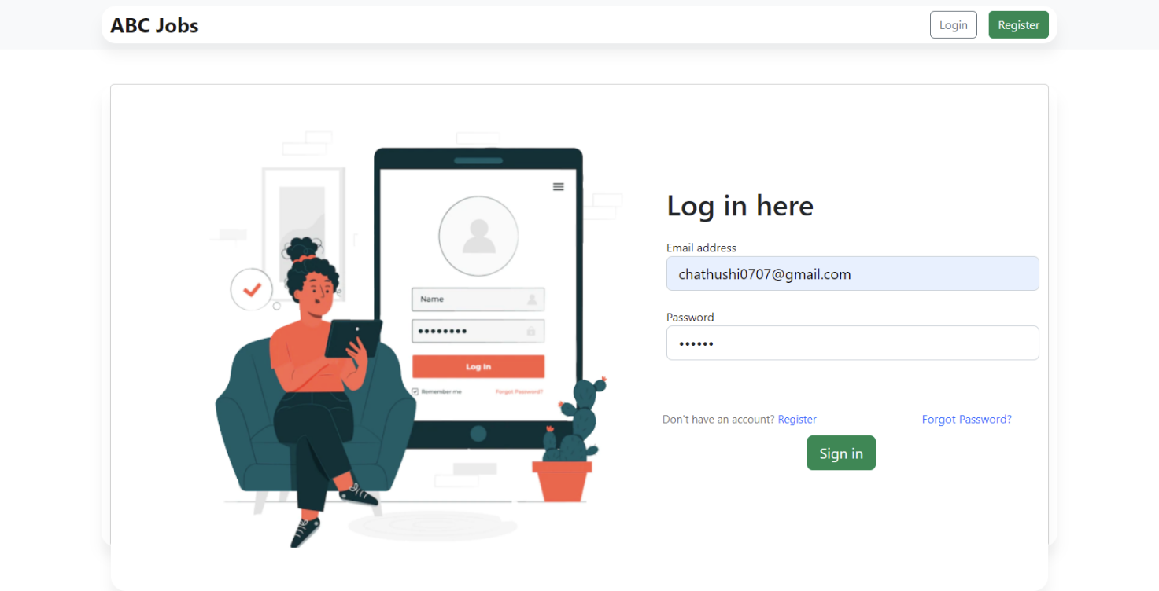

Figure :TS005 - UAT01(1) Screenshot of Login Page with details

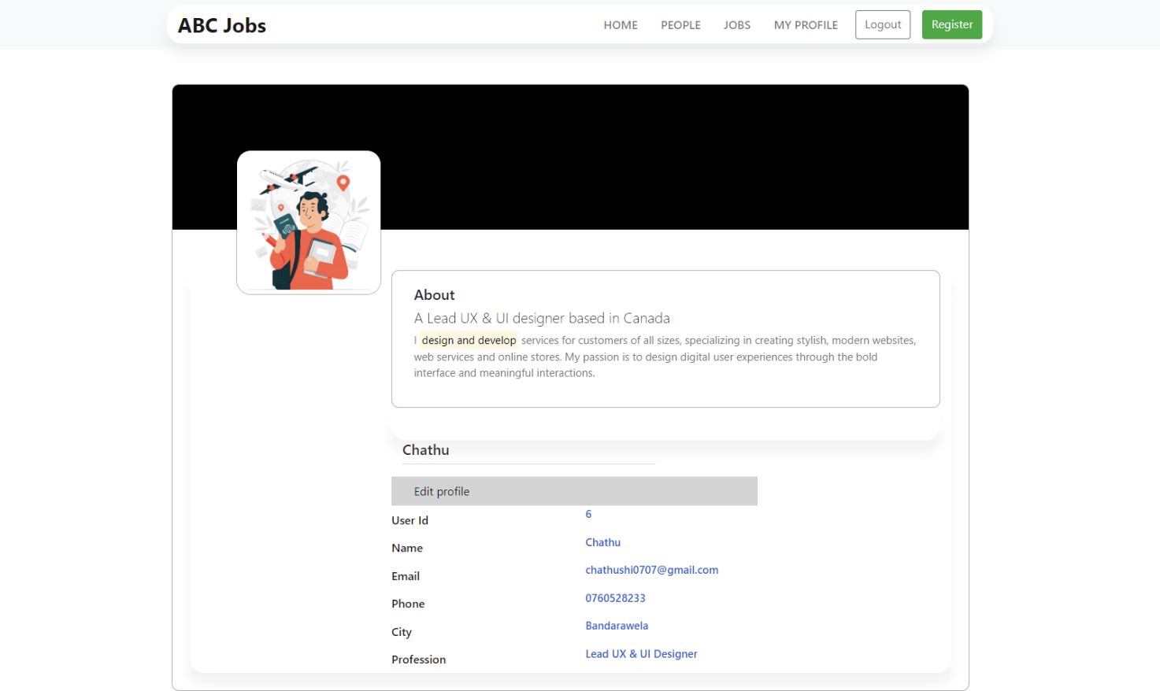

Figure :TS005 - UAT01(2) Screenshot of Login Page with details

**TS005 – UAT02(1)**



Figure :TS005 - UAT02(1) Screenshot of Login Page (Forgot Password)

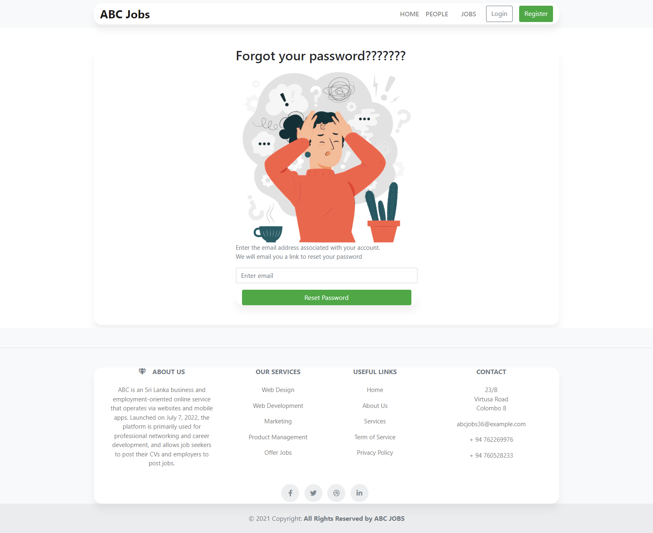

Figure :TS005 - UAT02(2) Screenshot of Forgot Password Page

|  |  |
| --- | --- |
| Test Scenario | Forgot Password |
| TS006 |
| Test Cases | **UAT Testing** |
| UAT01 | After giving the email and clicking reset password, check if a reset password link is sent to the email |
| UAT02 | Check reset password hyperlink menu is loading correct page |

|  |  |  |  |  |  |  |  |  |  |
| --- | --- | --- | --- | --- | --- | --- | --- | --- | --- |
| Scenario ID | Test Case ID | Test Case | Preconditions | Test Step | Test Data | Expected Results | Actual Results | Pass / Fail | Evidence |
| TS005 | UAT 01 | After giving the email and clicking reset password, check if a reset password link is sent to the email | The user should have the URL of the website and open a homepage of the abcjobportal.com | Go to Microsoft Edge  Type www.abcjobportal.com and enter  Click on all the links provided for test | Enter email address and click reset password | Receive temporary login link sent to email address | AS expected, | Pass | UAT  01(1)  UAT 01(2) |
| TS005 | UAT02 | Check reset password hyperlink menu is loading correct page | The user should have the URL of the website and open a homepage of the abcjobportal.com | Go to Microsoft Edge  Type www.abcjobportal.com and enter  Click on all the links provided for test | Enter email address and click reset password | Redirected to forgot password confirmation page | As expected, | Pass | UAT 02(1) |

**TS006 – UAT01(1)**

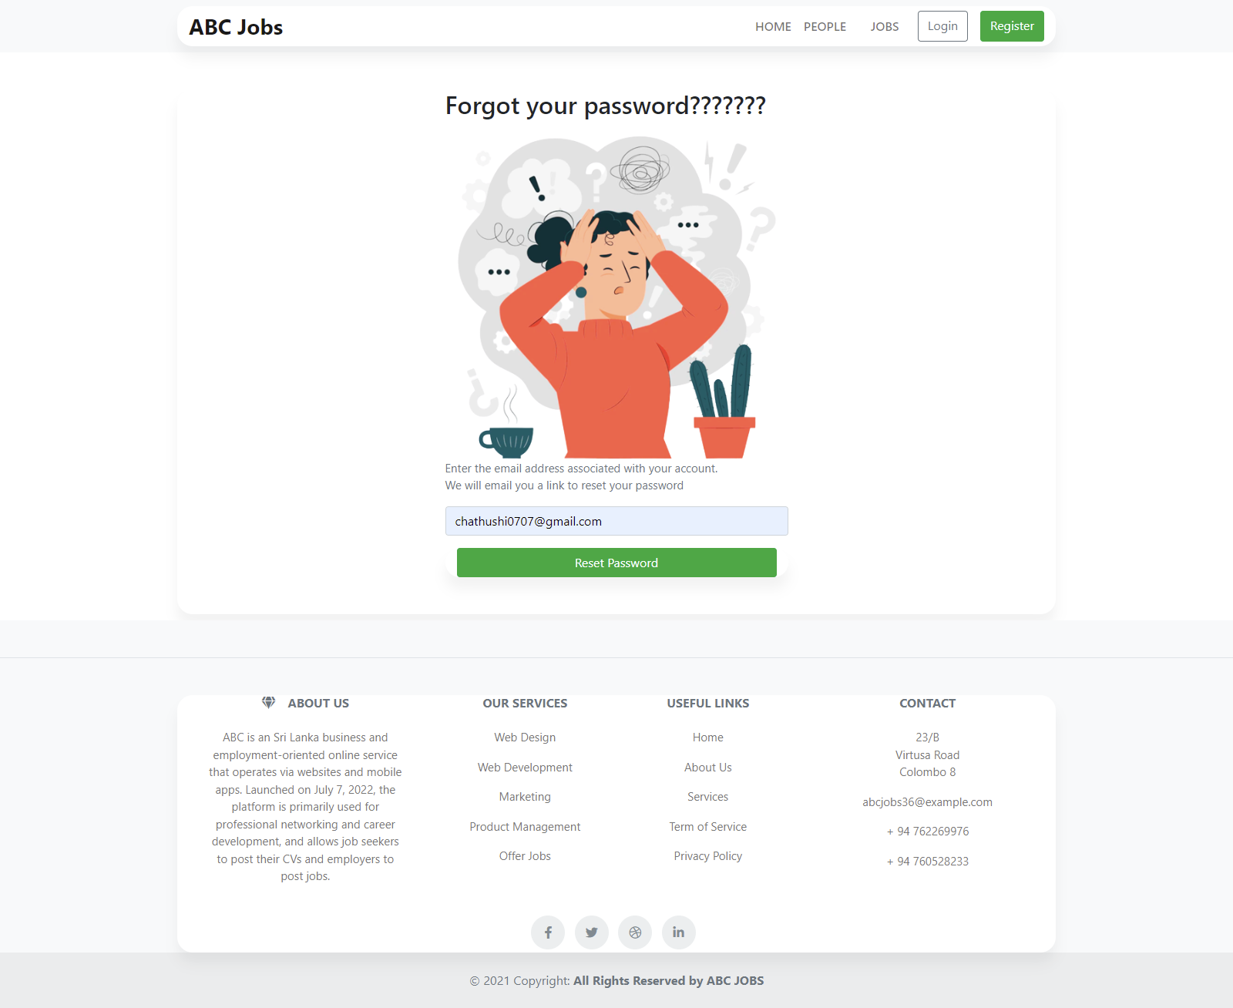

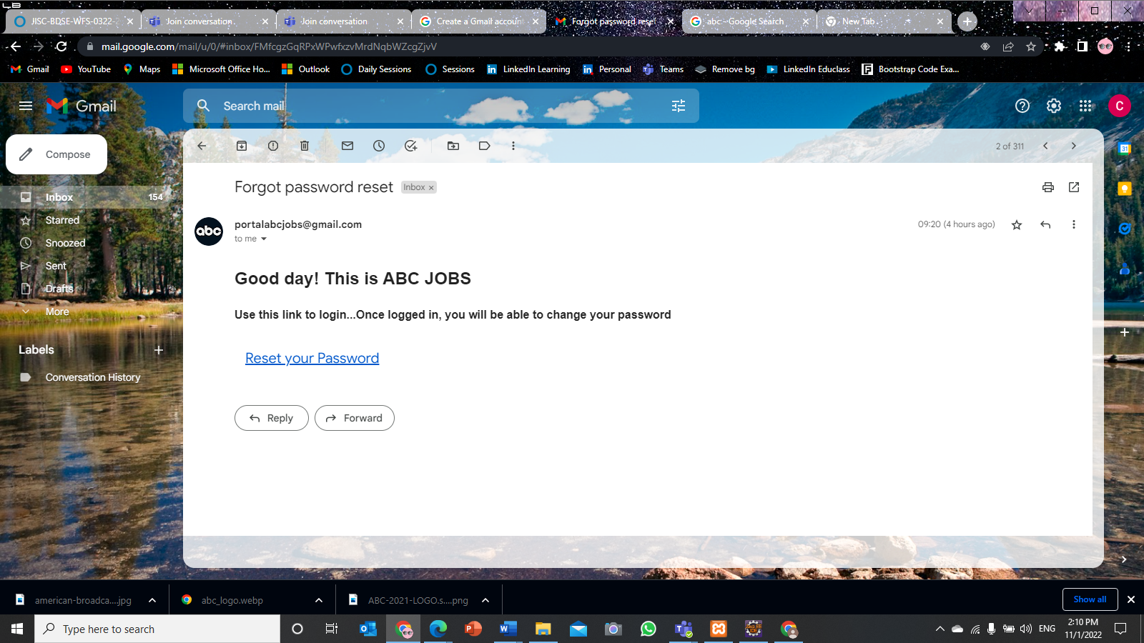Figure :TS006 - UAT01(1) Screenshot of reset password

Figure :TS006 – UAT01(2) Screenshot of received email from ABC Portal

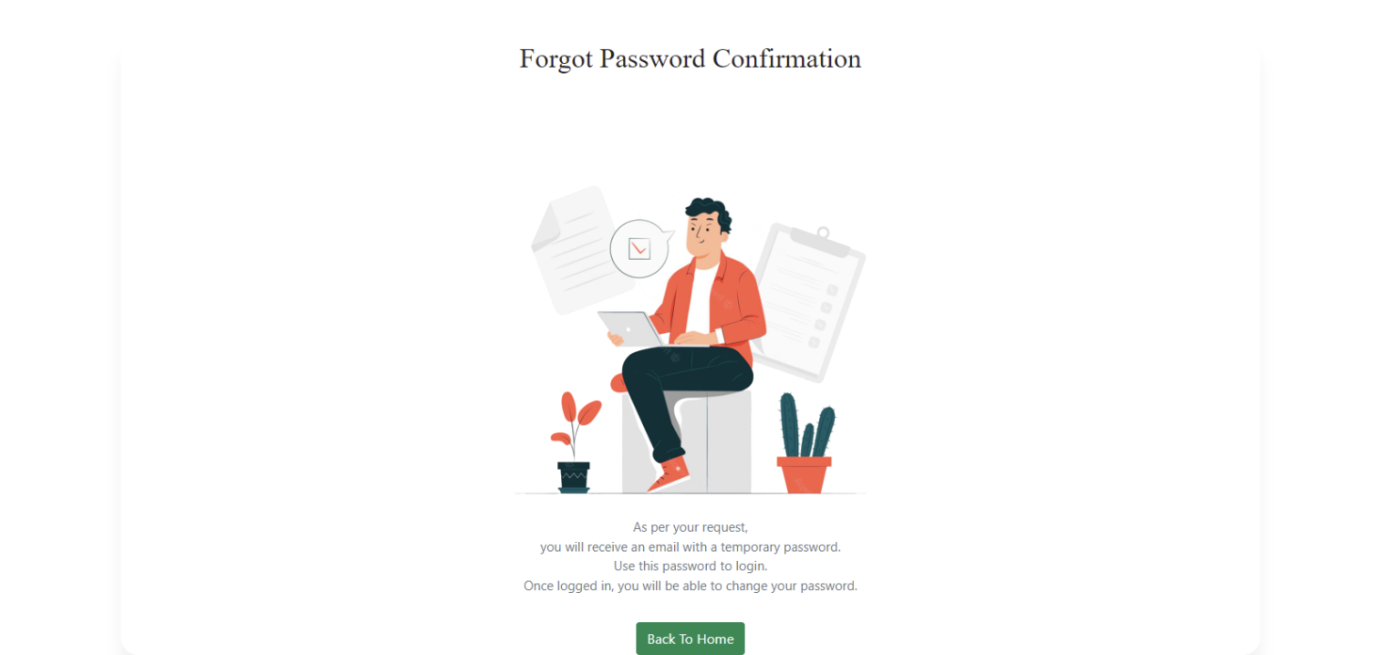**TS006 – UAT02(1)**

Figure :TS006 - UAT02(1) Screenshot of Forgot Password Confirmation

**Scenario 3: Cross Browser Testing**

|  |  |
| --- | --- |
| Test Scenario | Check that the application is run normally on multiple web browser |
| TS003 |
| Test Cases | **Cross Browser Testing** |
| CBT01 | Check browser can run on Mozilla Firefox web browser using lamdatest |
| CBT02 | Check browser can run on Google Chrome web browser using lamdatest |

|  |  |  |  |  |  |  |  |  |  |
| --- | --- | --- | --- | --- | --- | --- | --- | --- | --- |
| Scenario ID | Test Case ID | Test Case | Preconditions | Test Step | Test Data | Expected Results | Actual Results | Pass / Fail | Evidence |
| TS003 | CBT 01 | Check browser can run on Mozilla Firefox web browser using lamdatest | The user should have the URL of the website and open a homepage of the https://app.lambdatest.com/ | Go to Microsoft Edge  Type wwwhttps://app.lambdatest.com/and enter  And then click on real time testing and paste link there | ABC Jobs Portal website hosted in ngrok software | Run normally as it should | AS expected, | Pass | CBT  01(1) |
| TS003 | CBT02 | Check browser can run on Google Chrome web browser using lamdatest | The user should have the URL of the website and open a homepage of the abcjobportal.com | Go to Microsoft Edge  Type www.abcjobportal.com and enter  Click on all the links provided for test | ABC Jobs Portal website hosted in ngrok software | Run normally as it should | As expected, | Pass | CBT  02(1) |

**CBT 01(1)**

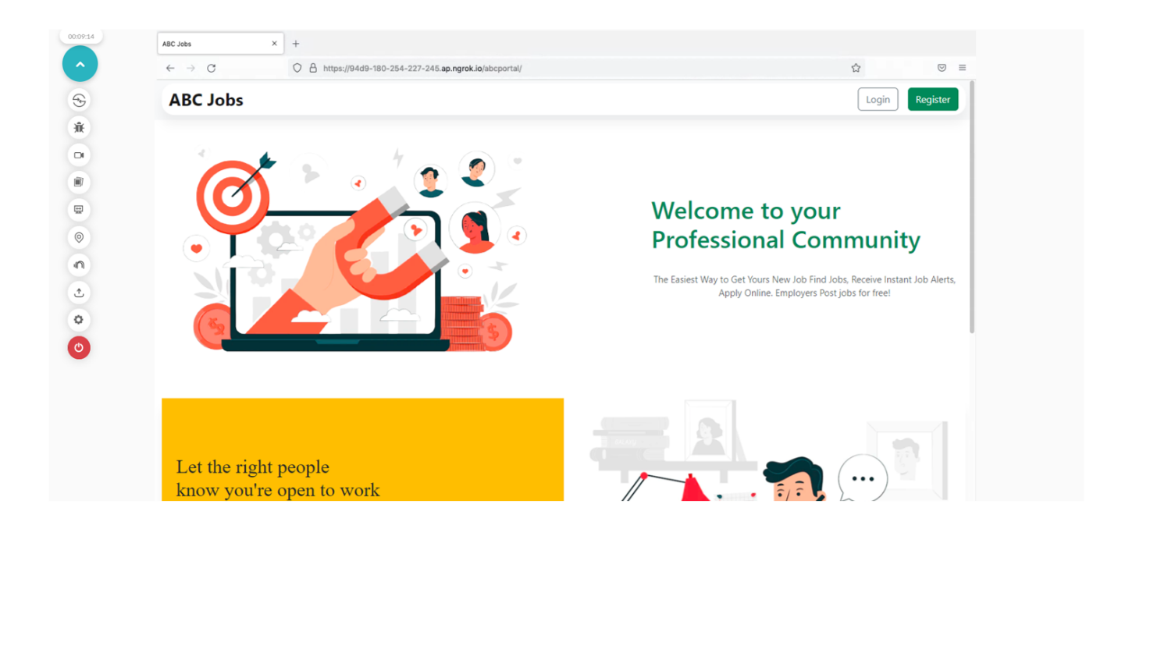

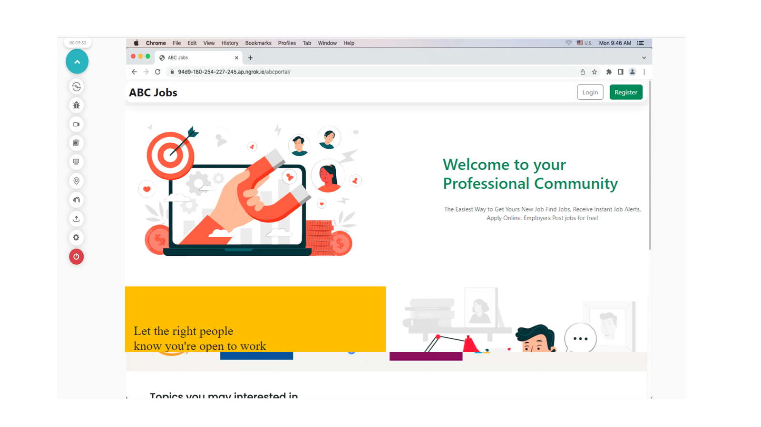**CBT 01(2)**

**References**

[www.youtube.com](http://www.youtube.com)

[www.w3school.com](http://www.w3school.com)

[www.stackoverflow.com](http://www.stackoverflow.com)